**Week 8 Assignment**

Om Prakash Shah

Sushant Acharya

Model Institute of Technology (MIT)

CSE 100: Fundamentals of Programming

Professor Banstola

June 27, 2025

Table of Contents

Abstract 3

Introduction 4

About the Project 4

Functionality / Components 5

Source Code 7

References 11

Appendix 12

# Abstract

The Quiz Game is a console-based C program designed to provide an interactive trivia experience. It reads questions from an external file, randomly selects five for each game session, and allows users to input answers to earn scores. The program stores player names and scores in a file, displays the highest scorer(s), and offers an option to view scores above a specified threshold. This documentation outlines the project's purpose, functionality, components, and source code, providing a comprehensive guide for users and developers.

# Introduction

## About the Project

The Quiz Game is a lightweight, text-based application developed in the C programming language to deliver an engaging and educational quiz experience. The program aims to test users' general knowledge across various topics through a set of multiple-choice questions. By leveraging file handling, it externalizes question data and persists user scores, enabling tracking of performance over time. The project is designed for simplicity and extensibility, allowing easy modification of questions and integration of additional features.

## Functionality / Components

The Quiz Game program includes the following key functionalities and components:

* **Question Loading**:
  + Reads questions, options, and correct answers from "questions.txt" in a CSV-like format.
  + Supports up to 100 questions, with 5 randomly selected for each quiz session.
* **Randomization**:
  + Uses a Fisher-Yates shuffle algorithm to randomize the order of questions, ensuring varied quiz sessions.
* **User Interaction**:
  + Prompts users to enter their name at the start.
  + Presents 5 multiple-choice questions, accepting answers as numbers (1-4).
  + Provides immediate feedback on correctness and displays the correct answer for incorrect responses.
* **Score Management**:
  + Tracks the user's score (out of 5) based on correct answers.
  + Saves the player's name and score to "scores.txt" in CSV format.
  + Displays performance-based messages (e.g., "Excellent job!" for scores ≥4).
* **High Score Features**:
  + Automatically displays the highest score and the name(s) of the player(s) who achieved it after each game.
  + Allows users to view scores above a specified threshold, enhancing competitive analysis.
* **File Handling**:
  + Reads questions from "questions.txt" and appends scores to "scores.txt".
  + Includes error handling for file operations to ensure robustness.

# Source Code

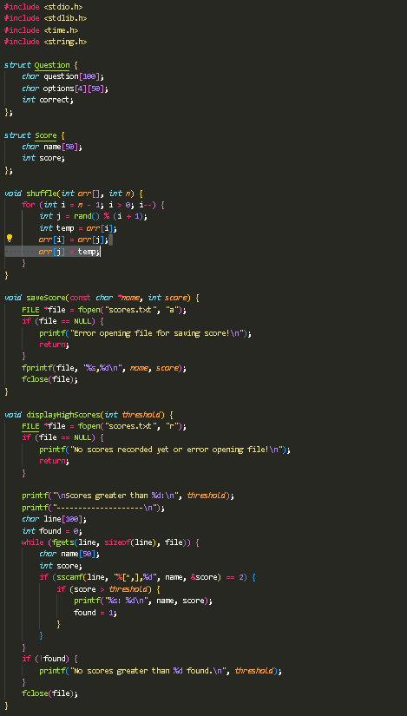

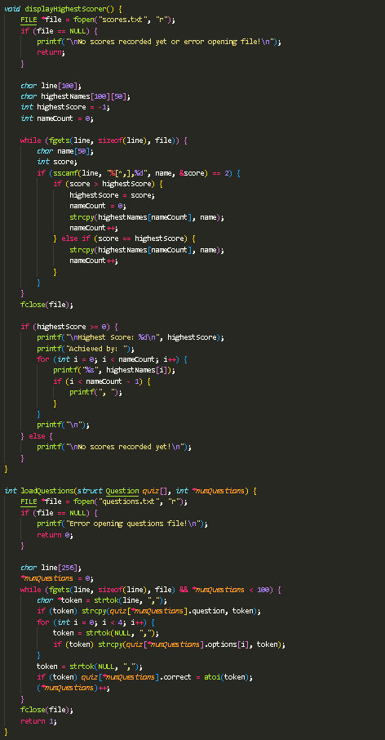

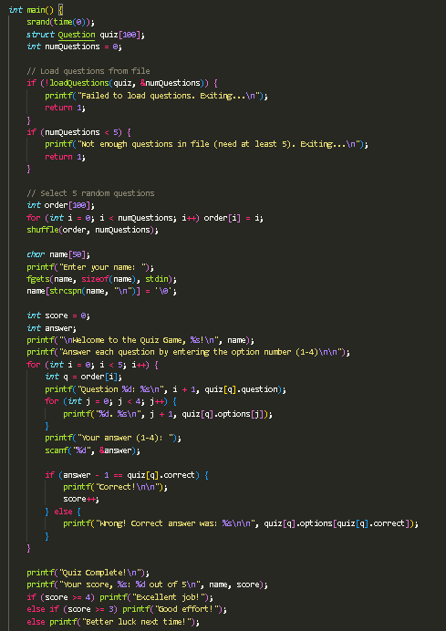

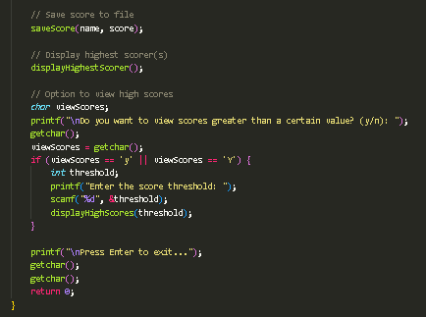

# References

Deitel, P., & Deitel, H. (2021). *C how to program* (9th ed.). Pearson Education.

Kernighan, B. W., & Ritchie, D. M. (1988). *The C programming language* (2nd ed.). Prentice Hall.

ISO. (2018). *Programming languages — C* (ISO/IEC 9899:2018). International Organization for Standardization.

The Open Group. (2018). *The single UNIX specification, version 4*. Retrieved from <https://pubs.opengroup.org/onlinepubs/9699919799/>

Harbison, S. P., & Steele, G. L. (2002). *C: A reference manual* (5th ed.). Prentice Hall.

Portfolio Courses (2021, Dec 26). *Shuffle An Array | C Programming Example* [Video]. YouTube <https://www.youtube.com/watch?v=7OIZ_W75lAM>

Programiz (2022, May 13). *#29: C File Handling | C Programming for Beginners* [Video]. YouTube <https://www.youtube.com/watch?v=MQIF-WMUOL8>

# Appendix

